**IT24103008**

**PS Lab Sheet 10**

Exercise

1. A vending machine owner claims that customers choose the four snack types (A, B, C, D) with equal probability. To test this claim, a researcher records the number of purchases for each snack type during one week and results are given below.

|  |  |
| --- | --- |
| **Snack_Type** | **Count** |
| A | 120 |
| B | 95 |
| C | 85 |
| D | 100 |

1. 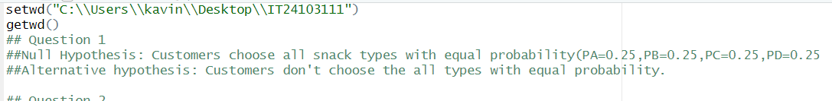State the null and alternative hypotheses for the test.

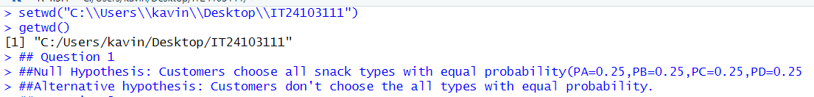

1. A white paper with black text and blue text

   AI-generated content may be incorrect.A math equations with numbers

   AI-generated content may be incorrect.Perform a suitable chi-squared test to test the null hypothesis
2. Give your conclusions based on the results.



